- 1 -

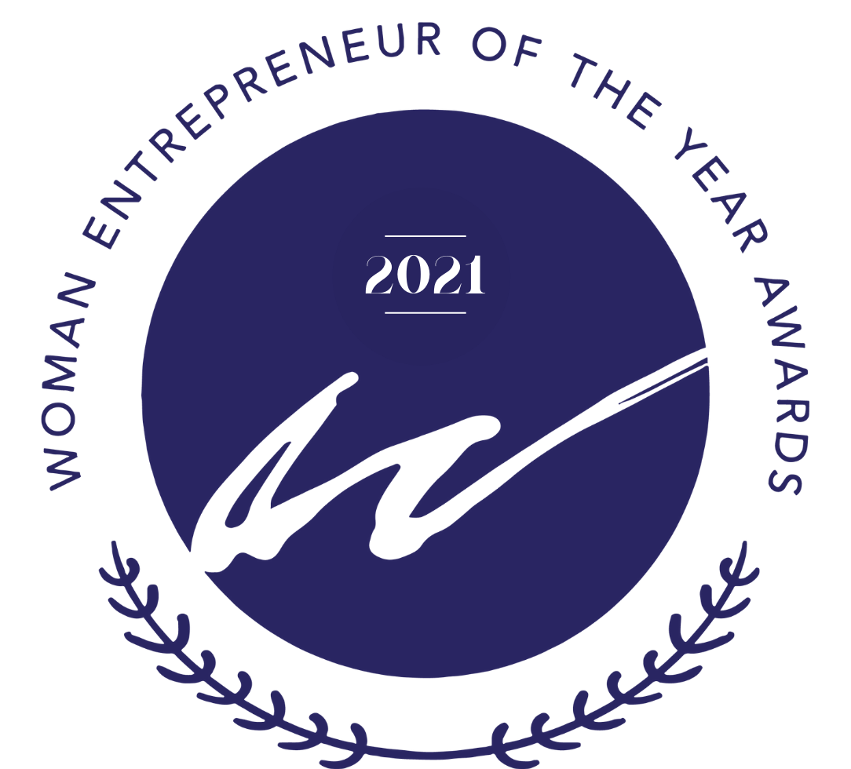

Submission Package 2021
Women Business Owners of Manitoba

WBOM, Women in Business

Guidelines
Woman Entrepreneur of the Year 2021

General Rules and Submission Guidelines

As a nominee for one of the Woman Entrepreneur of the Year Awards (WEYA), you are required to meet all the following criteria:

- Be either an equal partner, a 50% (or more) shareholder, or sole owner in a business registered and in operation in Manitoba.
- Be a member of WBOM, Women in Business at the time submissions are due.
- Be a major decision maker in the general operations of the business.
- Operate a full-time venture from which you draw a sustainable income.
- You will be required to submit your company financial information (year-end financial report for the past three years) in a sealed envelope no later than August 31, 2021.
*THIS INFORMATION WILL BE HELD IN THE STRICTEST CONFIDENCE and will only be reviewed if the application is selected as an award finalist. All financial information received will be destroyed.

Submission forms must be received by March 30, 2021, either by email to info@wbom.ca or mailed to:

23b - 845 Dakota Street, Suite 388 Winnipeg, MB R2M 5M3

Applications received after the deadline will not be accepted under any circumstances.

A photograph (headshot) and a digital copy of your organization’s logo must be submitted electronically with your package.

Legal Name of the Company: Owner Name(s):
Title:

Address:

Email:

Phone number:

Business category:

Tell us why you are great in business:

How is your business involved with, or how does it give back to the community?

Information Release
I understand that the information provided by my company will be used by WBOM, Women In Business and its panel of judges in selecting the finalists and award recipients. I consent to the use of my name, information, and any photographs or video recordings for this purpose and authorize the use of this information in promoting the event, during the awards ceremony, and in any media coverage.

Applicant’s Signature: ______________________________

Date:

Company Information (including vision, mission and value statement). Maximum words 250.

Business History: Why did you start the business? Include any risks that you’ve taken for your business to succeed and struggles you have encountered. Maximum words 500

Describe the products or services that set your company apart or give you a competitive advantage. Maximum 500 words

Growth Strategies: tell us about your growth goals and how you expect to achieve those goals. Maximum 250 words

Company Structure: Describe your workplace culture and how it supports you and your employees? How has Covid-19 impacted your business? How have you had to adapt? Maximum 500 words.

Accolades and Awards: List any associations or organizations that you belong to and identify any awards you have received in relation to your business. Maximum 250 words

References must include, and be forwarded with, your application form:
- 1 -­‐ 3 reference letters from a client
- 1 – 2 reference letters from a professional colleague
- 1 -­‐ 2 reference letters from a community-based organization (if applicable)

